Table of Contents
1 Target Audience 2
2 Technology Solutions - Resource Contacts 3
3 Introduction 4
4 Prerequisite Deployment Instructions for Docker Container 5
4.1 Setting BIOS to enable Virtualization. 5
4.2 Download the Docker Engine. 6
4.3 Install docker engine.exe 6

Revision History

Version | Date | Description of Changes | Revised by
0.1 | Feb 15, 2017 | - Initial | Arijit Chatterjee
0.2 | Feb 24,2017 | - Update | Arijit Chatterjee

Target Audience
The procedures in this document are intended to be executed by personnel (Tester, Developer, Architect or Business Analyst) to deploy Docker Images on docker container.

Technology Solutions - Resource Contacts
Supal K Chowdhury Sr. IT Architect (GBS India) supal.chowdhury@in.ibm.com/+919433065267
Arijit Chatterjee Developer (GBS India) arichatt@in.ibm.com/+919851647431
Sujoy Roy Sr System Analyst (GBS India) sujoroy1@in.ibm.com/
Radha Mohon Dey Master Inventor radhamde@in.ibm.com

Introduction
This document intends detailing the dockerized image deployment on docker Container.

Prerequisite Deployment Instructions for Docker Container

Setting BIOS to enable Virtualization.
Go to Bios in the setting tab.
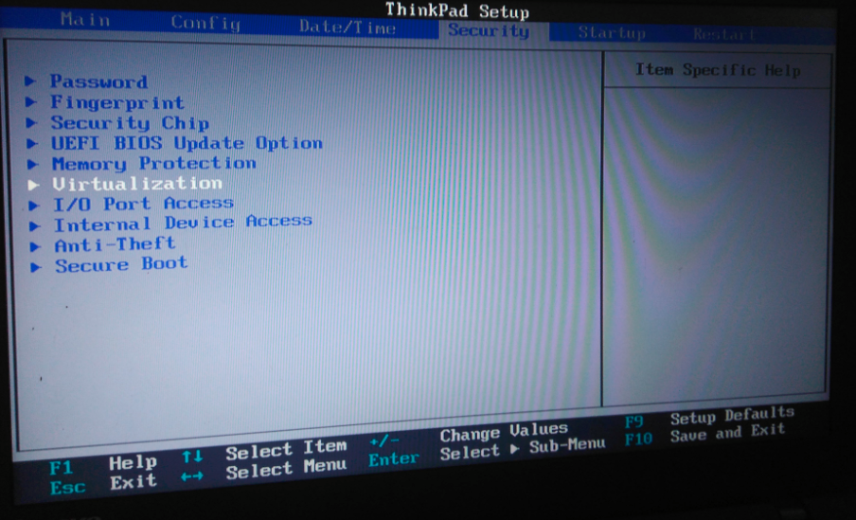

Go to virtualization and enable the virtialization.
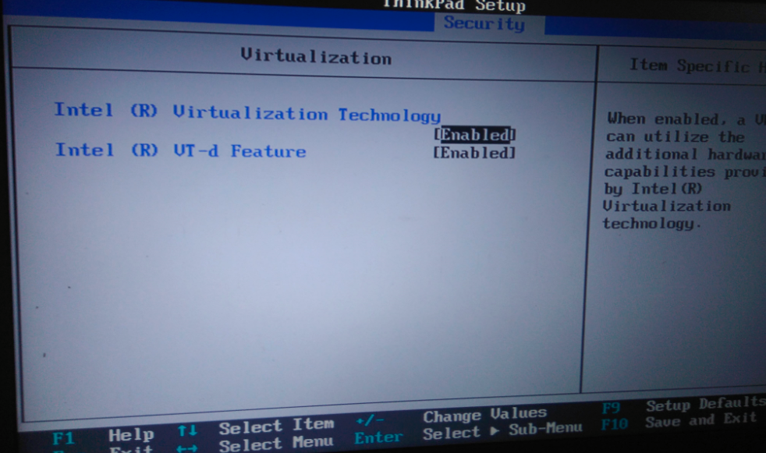

Download the Docker Engine.
  - Download the docker engine.exe file from the link in our local machine/server: https://docs.docker.com/docker-for-windows/
N.B : Make sure docker version should be :
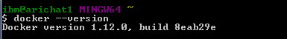

Install docker engine.exe
Click the exe to start the installation.
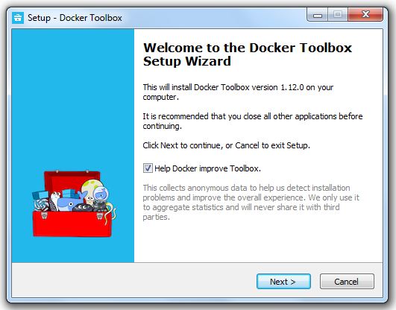

Click “Next”

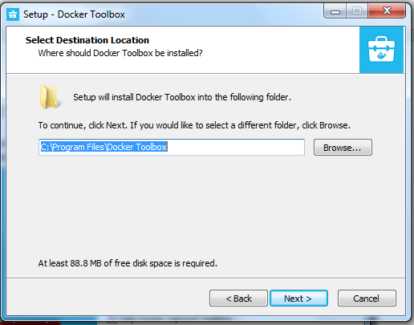

Click “Next”

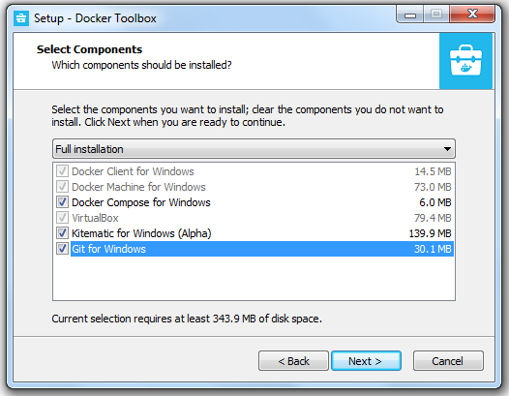

Click “Next”
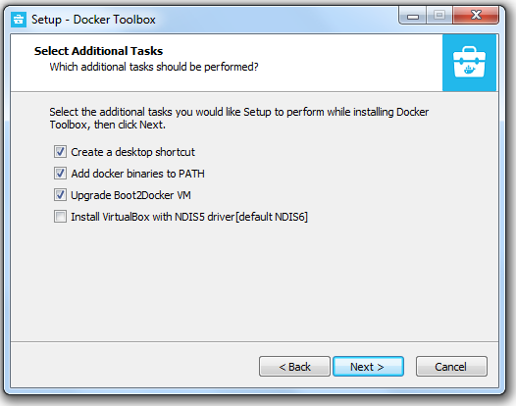

Click “Next”

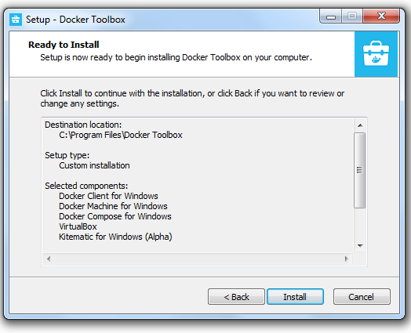

Click “Install”
The installtion may take few minutes.
Once installtion done ,you can able to see below screen.

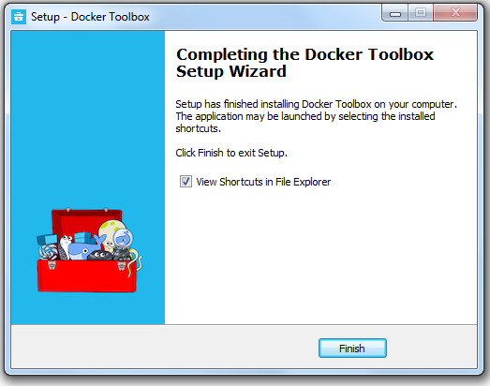

Clck “Finish”
Now in the desktop you can see the icons which are installed by the above task.

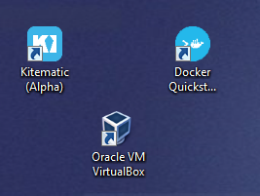

Click on “Docker Quickstart: icon to check the version of the docker engine.After clicking a command promt appear.Wait until this screen appear .

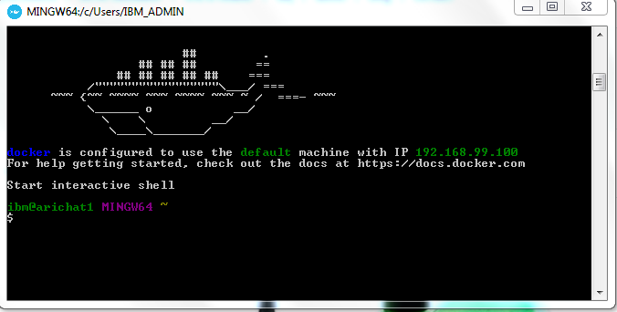

Confirm the version(1.12.0) by the command “docker --version”

